





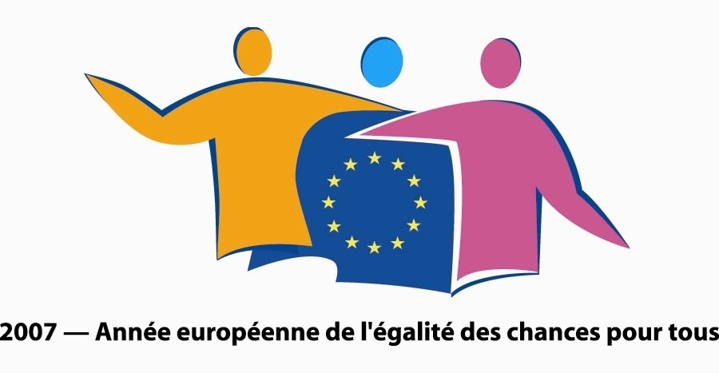



Babylon @ Cannes 16-24 May 2007
In Association with the Producers Network

www.babylon-film.eu

BABYLON is a feature film development initiative and cultural forum produced by Scenario Films (UK) in co-production with Ciné-Sud Promotion (France), and funded by the Centre National de la Cinématographie, Goethe-Institut, British Council and the UK Film Council.

It is aimed at Europe’s culturally diverse filmmakers and mixed creative teams seeking to broaden their international reach by working creatively together in a European context.

Europe is a continent of ethnic and cultural pluralism, but filmmakers of Europe’s varied minorities rarely have the chance to communicate across national boundaries. BABYLON is designed to fill this gap, a European space in which minority filmmakers can speak to each other and to the widest international audience.
Through a discovery of shared experience, BABYLON celebrates Europe’s cultural diversity, a motor for European integration, an affirmation of solidarity between filmmakers across the Continent.

Following the intensive three-day project development workshop during IFF Rotterdam in January, the Cannes Film Festival is the venue for BABYLON’s networking and financing event 16-23rd May in association with the Producers Network.

BABYLON projects participating at the Producers Network are:

L’IMPOSSIBLE TESTAMENT produced by Imed Marzouk of Propaganda Production, Tunisia, written and directed by Jilani Saadi;

SHANGHAI BELLEVILLE produced by Juliette Grandmont of Charivari Films, France, written and directed by Show-Chun Lee;

BLACK MARKET produced by Anthony Alleyne and Rachel McClelland of Rebel State Films, UK, written and directed by Anthony Alleyne;

BURNOUT written and directed by Sülbiye Günar contact producer Christoph Thoke;

BATTLE WITHOUT BANNERS by Faisal A. Qureshi contact producer Fiona Howe.

BABYLON projects participating at the Cannes Market are:

THE WAR IS OVER written and directed by Mitko Panov produced by Mitko Panov and Assaf Shapira;

FLIEH ELIF FLIEH written and directed by Seyhan Derin.

For a full list of the 2007 programme plus Babylon projects and participating filmmakers and producers, please visit www.babylon-film.eu/.

For information during the Producers Network please contact Fiona Howe and Gareth Jones on +44 7792 644325/+44 7985 969487 or Thierry Lenouvel on +336 893 551 06.




